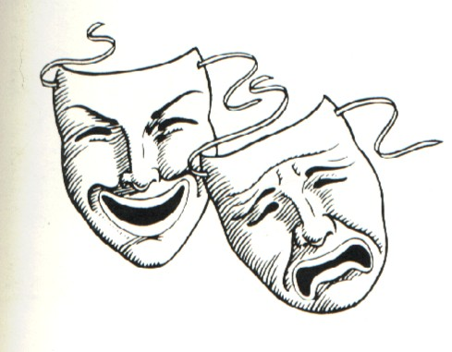
In-Class Scene

For this assignment you will be working with your suit-group to perform the final lines of the first scene of Romeo and Juliet. Starting at ln. 118 with Lady Montague, each group will be assigned a section of the scene to perform in front of the class.

The first step for this activity is to determine everyone’s task:

- The Director- (The head honcho) Responsible for unifying various aspects of production. The director's function is to ensure the quality and completeness of the theatre production (your scene) and to lead the members of the creative team into realizing their artistic vision for it. The director therefore collaborates with a team of creative individuals and determines how the scene will play out in class.

Take into account use of space.
Keeping the audience engaged.
Making sure the pacing is spot on and choreographed.

- The Reader- Responsible for reading the scene as the actors perform it. As well, the reader is responsible for speaking with a clear and loud voice, an appropriate tone, stress, expression, and energy.

- The Actors(tress) (2)- Responsible for reinterpreting the scene through use of gestures, facial expression, body language, and/or any nonverbal techniques. As well, the actors are responsible for coordinating with the reader who will be reading out the lines as you perform them.

- The Interpreter- Responsible for determining 2 spots during the scene where an aside can be made to the audience. In these asides the interpreter will provide a translation (explanation of difficult language) to reinforce what the scene is about. As well, the interpreter must coordinate with the reader and actors to figure out when to pause the scene (everybody freezes) in order for the aside to be made.

