Name:________________________
Music and Mood
Music Matching
Assignment

Directions:
At the end of each act of Romeo and Juliet your task will be to choose a song that
reflects the mood. However, for the first task you will choose a song that sets the
mood for the whole play by choosing a song that reflects the prologue.

Examples that Ms. Kaufmann used in class:

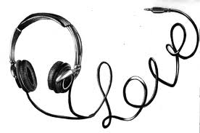

- Song Choice for the Prologue: _________________________ Artist:_________________________

- Print out and Attach Lyrics, if your song has lyrics. (Make sure they are appropriate!)

- Determine the mood of the song using the Mood Word List attached
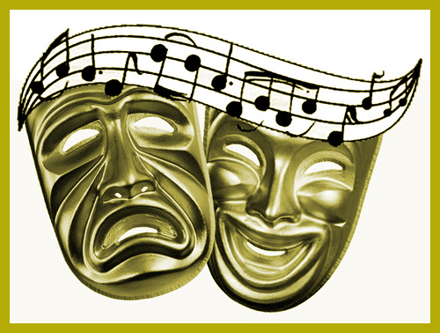

- Give 3 examples as to how determined the mood.
If your song has words, underline 3 words in your song that are descriptive/indicative of the mood.

- How does the music of the song – the rhyme scheme, the beat and the vocals – reflect the prologue and set the stage for the play? (1 Sentence) Why did you choose this song? (1 Sentence)

